Appendix C

1. Interface Design

1.1 ) Consistency

By exploitation common parts in my UI, users feel easier and are able to get things done a lot of quickly. it's additionally vital to make patterns in language, layout and style throughout the location to assist facilitate potency

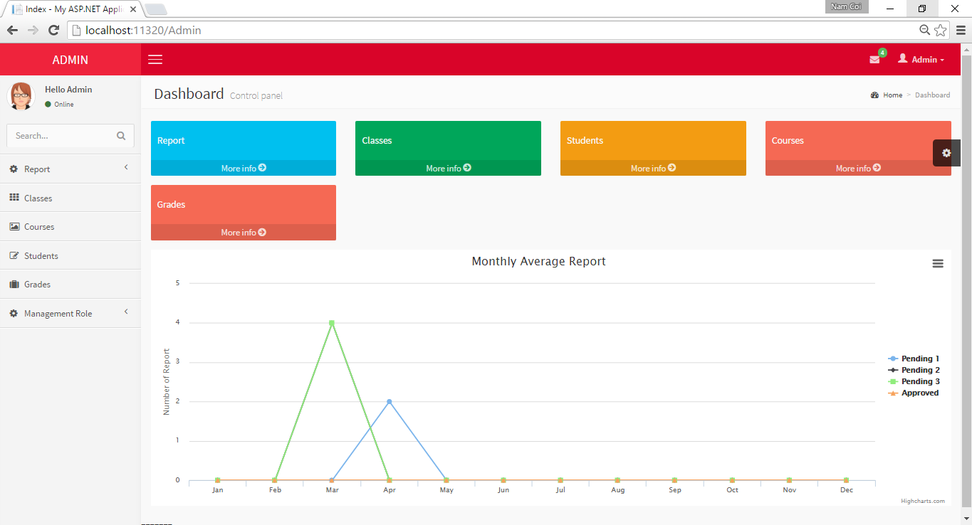

*Admin Home Page*

Consistency in our UI design: Consistency in our UI design: elements with similar actions/tasks should have an identical look. elements with completely different actions/tasks should have a distinct look

* Styling in our UI design:
* Header: name of the system on top left, and name of user on top right

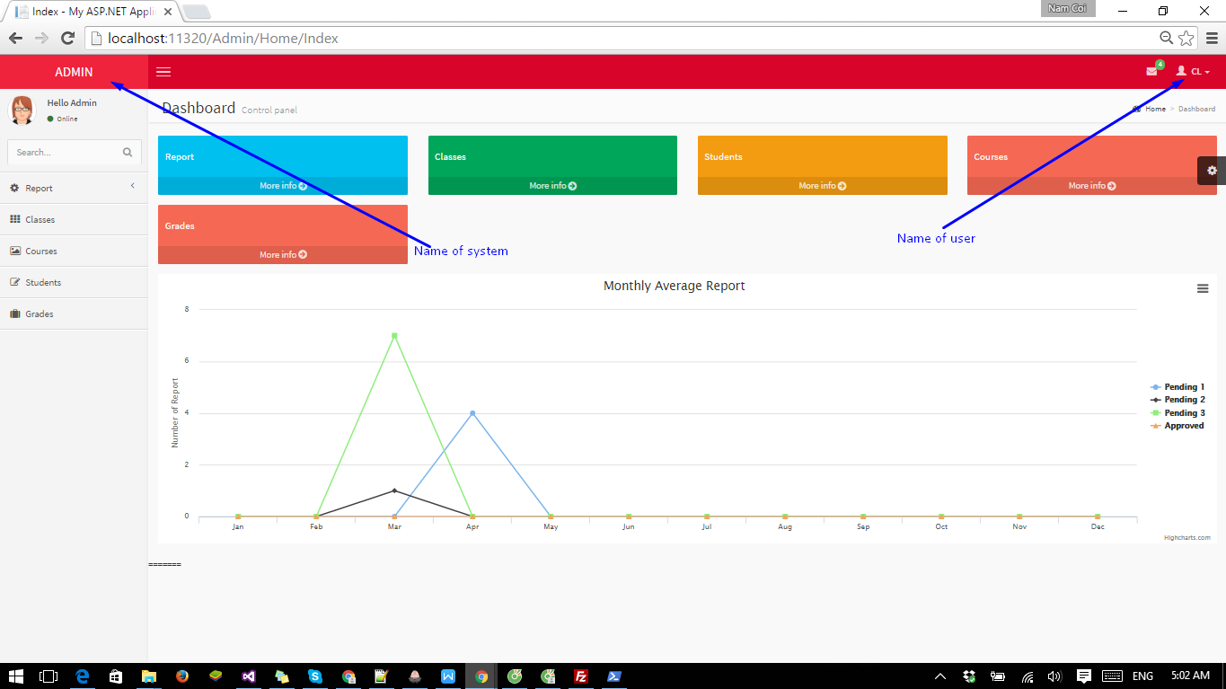

*Header*

* Body/Content: below header, about 95% total area of the page.
* Menu Bar: in the left of the page.

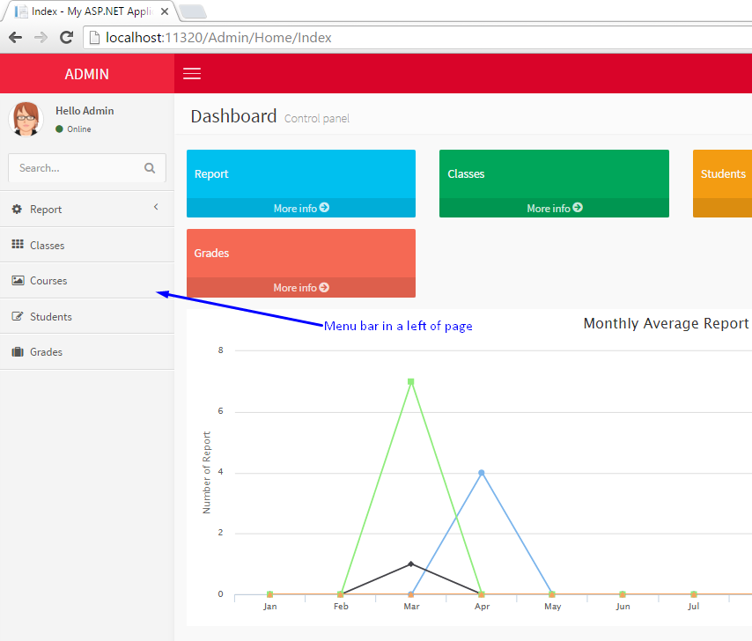

*Menu bar*

* Each type of content has its own style (different font, weight, color, etc.).
* This styling is applied in all page, for all users, for all roles.

- Consistency in our UI design is expressed across these style attributes:

* Color: only has few main colors. Same elements with same tasks have a similar colors
* Size: buttons with same tasks have same size.
* form and proportion: buttons have rounded corners, glows once hover mouse.

1.2 ) Visibility

The UI design must enable users easly to use and to have an overall view of things.

In our UI design, we organized components divided 2 column in center of body so users can easily follow, the spaces between components are reasonable.

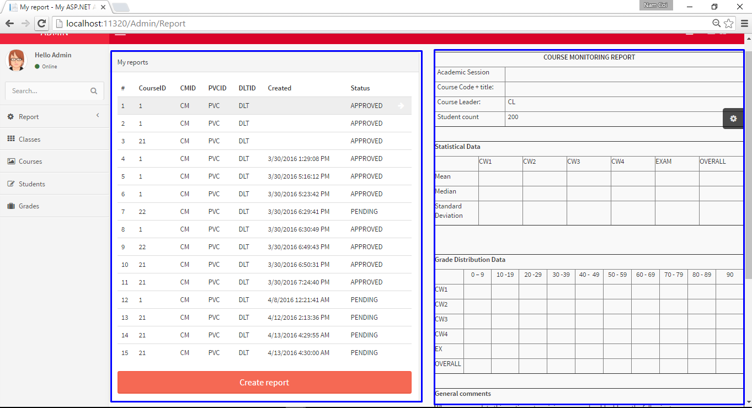

1.3 ) Learnability

One of the tasks of designer is creating users learn and keep in mind a way to use our product.

Therefore, we tend to should create our interfaces intuitive. It merely suggests that creating our style is clear, consistent and visual enough that users are ready to simply bear in mind what to try and do first, second, third, etc.

These are some design principles we use to improve the learnability of our UI design:

- create the UI simple as possible, so users not take much time to learn it and they feel comfortable when using the product.

- solely use enough UI elements for users to perform this task and method to the next task.

1.4 ) Predictability

The goals of UI styles are serving to users to understand wherever they're within the system at the moment, what a lot of will they are doing. Those goals will make user feel this product very smart. So they will keep using our product.

These are some design principles we used to help improve our UI design:

- Labels, icons and buttons tell us:

+ what to do (Button “Create”, “Edit”, “Delete”, “Details”)

+ where you’ll go (Menu Bar, Title of function, etc)